Lecture 9 b
Chemistry 2
(Biochemistry)

Desert land and reclamation program
Level 1

Presented By
Prof.Dr. Ahmed A. Abdelrahman

Classification of Lipids:
Derived lipids | Compound lipids | Simple lipids
-These are substances derived from simple lipids and compound lipids by hydrolysis  . Also, include substance related to lipids  1- Fatty acids. 2- glycerol. 3- Steroid. 4- Isoprenoids. 5- Eicosanoids | -They are formed of : -Lipid component + -Non-lipid component  1- Phospholipids. 2- Glycolipids. 3- Sulpholipids. 4. lipoproteins | -They are formed of fatty acids and alcohol  1- Fats and Oils 2- Waxes

1- Simple Lipids :
Simple lipids are esters of fatty acids with different types of alcohols. The alcohol may be glycerol (trihydric alcohol) or other long alcohol. ♣ R1 – COOH + R1 – OH ----------- RCOOR1 + H2O ♣ Fatty acid + Alcohol Ester + Water Simple lipids are classified into: fats, oils and waxes, according to the type of alcohol they contain.
1-Fats and oils(neutral fats) They are esters of : fatty acids with glycerol. They are similar chemically, but they differ in physical properties: as oils are liquid while fats are solid at room temperature. They are called triglycerides because they are triesters formed of glycerol and 3 fatty acids.

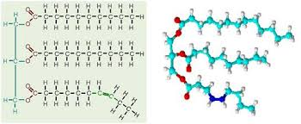

Oil: is a triacylglycerol that is liquid at room temperature.Made by more unsaturated fatty acids (Unsaturated triacylglycerols).Corn, cotton seed, safflower and sunflower (plant sources).
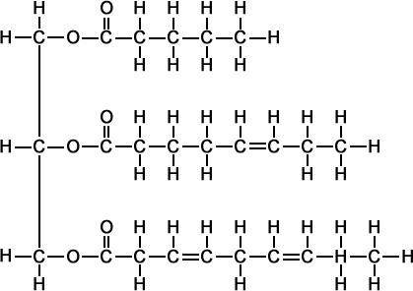
Triglycerides (TG) may be :
a- Simple TG: The fatty acids are the same e.g. palmitic or stearic acids forming>>>> tripalmitate or tristearate respectively.
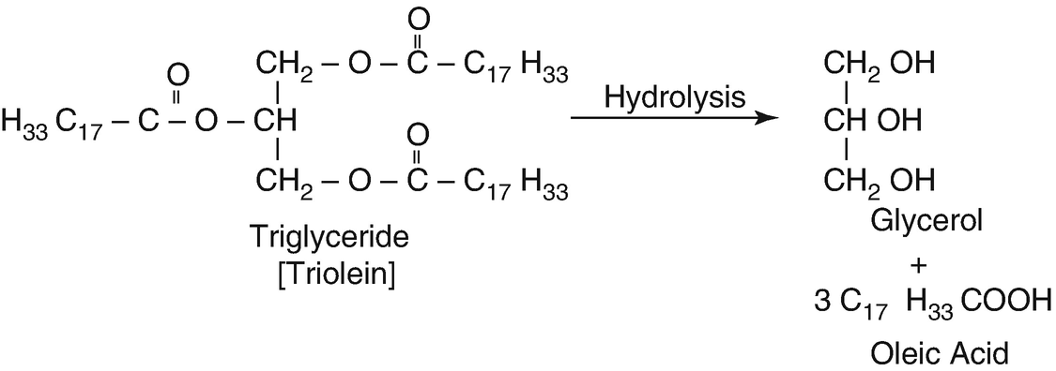
b- Mixed TG: Triglycerides with 3 different fatty acids.
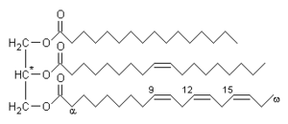
2- Waxes They are esters of fatty acids + Long chain Monohydric alcohol. They are solid at room temperature. The most important waxes in human body are cholesterol esters, which are present in blood and other tissues.
Waxes | Fats and oils
Solid  Absent  Present  Negative  undergo rancidity  Not Digested by lipase  Can not be utilized | Fats are solid Oils are liquid  Present  Absent  Positive  rancidity Not  digested by lipase  Can be utilized | Consistency at room temperature  Glycerol  Long chain alcohol  Acrolein test  Rancidity undergo  Digestion  Utilization by human
1- Waxes :
a) are liquid at room temperature.
b) have positive acrolin test.
c) ester of long chain alcohol with a single fatty acid
d) can be digested by human
2 - Complex lipids
Complex Lipids (Phosholipids, Glycolipids and Lipoproteins)
**Complex lipids: (a. Phospholipids)
• Made up of fatty acid, glycerol or other alcohol, phosphoric acid and nitrogenous base. • phospholipids are amphipathic in nature Tail (Non polar, hydrophobic) Head (Polar, hydrophilic)
b. Sphingolipids
Present in the brain and formed a quarter of the weight of the brain
3. Derived lipids Such as:
Fatty acids – diacylglycerols - Vitamins A,D,E,K

Activity
1-Give the hydrolytic product of : - Tripalmitin. - Cholesterol wax.
2-Compare between neutral fat and waxes.

Choose the best correct answer :
1- Lipids are formed mainly of alcohol and fatty acids combined together by:
a) ether link.
b) peptide bond.
c) glycosidic bond.
d) ester bond

